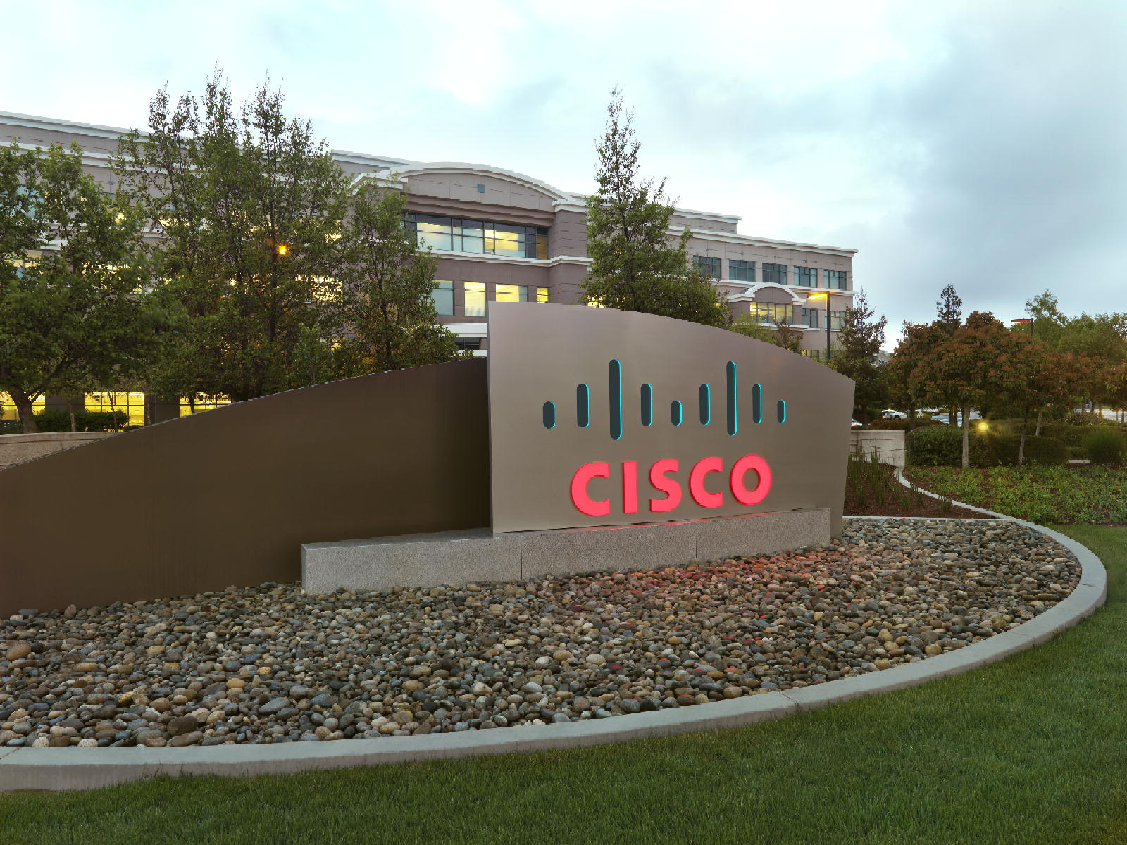

Advanced Service Assets

“PDTool” Promotion and Deployment Tool
Data Sheet
Data Virtualization Business Unit Advanced Services
March 2015

TABLE OF CONTENTS
INTRODUCTION 4
License 4
Purpose 4
Audience 5
Problem definition 6
What is the problem? 6
What is promotion? 6
Deployment 6
Configuration 6
Version Control 6
Testing 6
design philosophy 7
Modularity 7
What makes up a Module 7
Promotion Scenarios 7
Scenario 1 – Local CAR file based Deployment 8
Scenario 2 – Local VCS based Deployment 8
Scenario 3 – Remote VCS or CAR based Deployment 8
Composite Studio VCs integration matrix 9
PD Tool Studio 9
promotion and deployment matrix 10
PD Tool Capabilities 10
conclusion 11
How to get the Composite PS Promotion and Deployment Tool? 11

Document Control

Version History
Version | Date | Author | Description
1.0 | 2012 | Mike Tinius | Initial revision
2.0 | 3/4/2015 | Mike Tinius | Updated docs to Cisco format.

Related Documents
Document |  | Author

Data Virtualization Business Unit (DVBU) Products Referenced
DVBU Product Name | Version
Composite Information Server | 6.2, 7.0
INTRODUCTION

License
(c) 2014 Cisco and/or its affiliates. All rights reserved.
This software is released under the Eclipse Public License. The details can be found in the file LICENSE. Any dependent libraries supplied by third parties are provided under their own open source licenses as described in their own LICENSE files, generally named .LICENSE.txt. The libraries supplied by Cisco as part of the Composite Information Server/Cisco Data Virtualization Server, particularly csadmin-XXXX.jar, csarchive-XXXX.jar, csbase-XXXX.jar, csclient-XXXX.jar, cscommon-XXXX.jar, csext-XXXX.jar, csjdbc-XXXX.jar, csserverutil-XXXX.jar, csserver-XXXX.jar, cswebapi-XXXX.jar, and customproc-XXXX.jar (where -XXXX is an optional version number) are provided as a convenience, but are covered under the licensing for the Composite Information Server/Cisco Data Virtualization Server. They cannot be used in any way except through a valid license for that product.
This software is released AS-IS!. Support for this software is not covered by standard maintenance agreements with Cisco. Any support for this software by Cisco would be covered by paid consulting agreements, and would be billable work.

Purpose
The purpose of this document is to give Composite Customers a high-level description of the Composite PS Promotion and Deployment Tool (PD Tool).
The Composite Promotion and Deployment Tool (PD Tool) supports Composite Information Server 6.2+ and consists of three major components:
- PD Tool Studio – PD Tool Studio provides Composite Studio Version Control System (VCS) integration with easy-to-configure scripts.
- PD Tool – PD Tool provides an out-of-the-box, automated, configurable, promotion and deployment tool-kit to allow customers to promote CIS resources to target CIS servers such as test and production. This capability seeks to satisfy 90% of customer’s requirements for promoting CIS resources from one environment to another without the customer having to write any custom scripts.
- PDTool Testing – PDTool Regression Module provide the ability to perform testing against on a target CIS server. Testing can be broken down into these primary areas:
  - Functional Testing – test whether a published virtual view, procedure or web service is functional. This is a basic smoke test.
  - Migration Testing – test and compare the results from one release of CIS to another release of CIS. Insure there are no differences in results.
  - Regression Testing – test and compare the results from one release of code to the next. Insure there are no differences in results.
  - Performance Testing – test the performance of a set of queries or web services. Compare the overall response times from one set of tests with another to determine if performance increased, decreased, or was within an acceptable range.
  - Security Testing – test the accessibility by different users/groups across a range of groups and queries. Determine if a group is not set correctly or if there is a security hole.
This document provides:
- Composite Studio VCS Integration Matrix – This matrix provides the set of features for PD Tool Studio which is used to integrate Composite Studio with a VCS product.
- Promotion and Deployment Matrix – This matrix provides the set of features for PD Tool which is used for promoting resources from one CIS server to another.

Audience
This document is intended to provide guidance for the following users:
- Cisco (Composite) Customers
Problem definition

What is the problem?
Every customer must promote CIS resources from one CIS environment to another. Without a methodology or scripts, it is a manual process. Version Control Systems (VCS) add another complexity to the problem definition as some customers want to be able to deploy CIS assets directly from a VCS such as subversion.

What is promotion?
Promotion is the task of moving a CIS resource such as a view or procedure and configuring that asset according to the environment that it is being moved to. Promotion encompasses the entire process and takes a holistic view of an environment.
- Requirements – Some customers have rigorous and demanding deployment requirements and some have none.
- Variety – There are a variety of environments supported by Composite including Windows and various flavors of UNIX.
- Paradigm – CIS resources may be under source control and some may not. This affects the deployment paradigm.

Deployment
Deployment is the task of importing the CIS resources into the target Composite instance or cluster.

Configuration
Configuration is the task of modifying a CIS resource in the target Composite instance or cluster. One example of configuration is that data sources in development have a different hostname and password than data sources in test, UAT and production. It is necessary to tweak certain configuration parameters based on the environment that the CIS resources are being promoted into.

Version Control
Version Control Systems (VCS) provide a way to save different versions of the CIS resources. Many customers want to be able to deploy those code assets directly from the VCS to a target CIS server.

Testing
Many customers already have a framework in place for doing automated testing. PDTool offers enhanced integration with CIS in order to test virtual relational and web service resources.

design philosophy

Modularity
PD Tool provides a modular framework so that each functional module can stand on its own. Additionally new functionality can easily be plugged in over time. Existing modules can be swapped out for customized modules if needed using the Apache Spring framework.

What makes up a Module
A Module is a functional grouping of actions. An action can be anything that affects a change to a CIS resource or the CIS environment. For example, the “Archive Module” contains actions for import and export. The “Data Source Module” contains actions for re-introspect and update. The way in which a user affects change to CIS is by configuring the XML property file associate with a Module. To summarize, a module is made up of the following items:
- Module Name – The name and implementation of the Module.
- Module Action – The action(s) to be performed against a CIS instance.
- Module XML Property File – The XML property file located in PDTool\resources\modules

Promotion Scenarios
The Promotion and Deployment Tool supports command line and Ant execution in both Windows and UNIX environments. It will also support local and remote deployments. It will support Composite CAR file and Version Control System (VCS) based deployments.
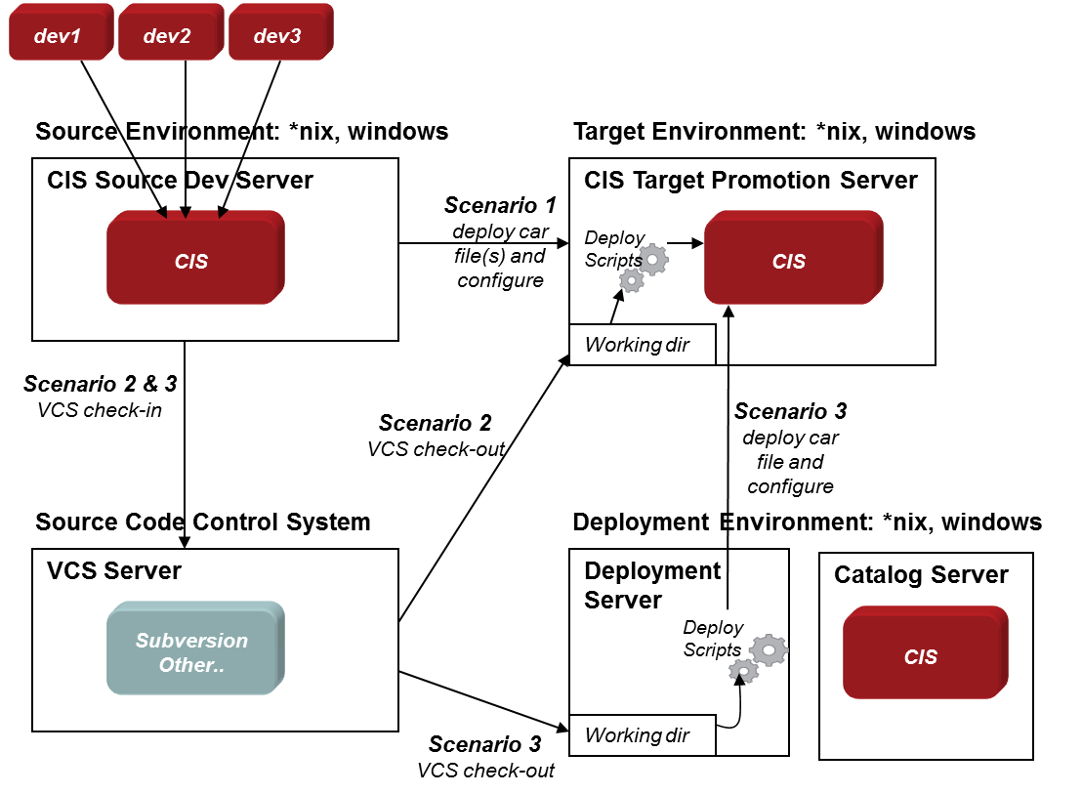
Figure 1 – Deployment Scenarios
The diagram depicts the three scenarios and will be described in more detail the ensuing sections. The diagram shows several individual developer workstations feeding changes into a central Composite Development Server. The process of getting changes into the Central Development Server is outside the scope of the Promotion and Deployment Tool. The scenarios pick at the point where a deployment is too occur starting with artifacts found in the Central Development Server. The CIS Target Promotion Server is where the artifacts will be moved to. A Target server is representative of CIS instance such as Test, Integration, UAT, and Production. Customers have different names for these CIS instances. The point is with promotion is that there is a source CIS instance and a target CIS instance. When performing promotion with version control, there will also be a VCS server which is used to check-in and check-out artifacts from Composite. Finally, the entire promotion process may need to be executed from a remote server instead of being run on the Target server.

Scenario 1 – Local CAR file based Deployment
In this scenario the scripts are executed locally on the Target Promotion Server. The PD Tool imports a CAR file into the target CIS instance and then executes various configuration actions on the target server.

Scenario 2 – Local VCS based Deployment
In this scenario, the Target Promotion Server is executing the promotion process. Instead of CAR files, the PD Tool is interfacing with a VCS server to check-out the specified artifacts, build a car file on the fly and then import into the Target Promotion Server. Additionally, the PD Tool will execute various configuration actions on the target CIS instance.

Scenario 3 – Remote VCS or CAR based Deployment
In this scenario, the Target Promotion Server is not involved in executing the PD Tool. Instead, there is a dedicated server that will execute the PD Tool. The remote promotion server would interface with VCS to check-out the specified CIS resources, build a car file on the fly and remotely import into the Target CIS Promotion instance. Similarly, if VCS was not involved, it could export specified CIS artifacts from the source CIS instance and import into the target instance. Finally, the Remote Promotion Server would remotely connect to the target CIS instance and execute various configuration actions. A CIS instance is not required on the deployment server for the PD Tool to function.
Composite Studio VCs integration matrix

PD Tool Studio
The following matrix provides a feature list of PS Promotion and Deployment Tool for Studio:
- PDTool Studio Feature Matrix

Feature | PD Tool Studio
Windows XP, 7 | Yes
Installation | Easy
Single-Node (Studio & Server) | Yes
Multi-Node (Multiple Studio & Server) | Yes
Multi-User (Multiple Studios / Central Dev. Server) | Yes
Subversion | Yes
Perforce | Yes
Concurrent Versions System (CVS) | Yes
Team Foundation Server (TFS) | Yes
Upgrade Impact | None
Configurable:  VCS Home:  VCS Command Line Options:  VCS Workspace Initialization Options  VCS Check-in Options  VCS Check-out Options  VCS Environment Variables: | Yes  Yes  Yes  Yes  Yes  Yes

promotion and deployment matrix

PD Tool Capabilities
The following matrix provides a feature list of PS Promotion and Deployment Tool:
- PDTool Feature Matrix

PD Tool Feature | Description
Automated Promotion and Deployment | Scripted CIS resource promotion using scripts and deployment plans.
Command-Line Execution Scripts | Execute a Deployment Plan using Command-line scripts
Ant Build Execution Scripts | Execute a Deployment Plan using Ant scripts
VCS-based Promotion | Check-out from VCS and import to target CIS Server
Archive-based Promotion | Use traditional CAR file based deployment
Local Promotion | Execute Promotion to Local CIS Server
Remote Promotion | Execute Promotion to Remote CIS Server (CIS not required on deployment server)
Modular Design | Modular architecture allows for maximum flexibility and the ability to add modules in the future.
Archive Module | Performs traditional Import, Export, Backup, Restore
Data Source Module | Generate Data Source Module XML file. Update Data Source configurations. Enable and Re-introspect Data Source.
Group Module | Generate Group Module XML file. Create or Update Groups. Delete Groups. Add users to groups. Delete users from groups.
Privilege Module | Generate Privilege Module XML file. Update Privileges.
Rebind Module | Generate Rebind Module XML file. Rebind Resources. Rebind Folders.
Regression Module | Perform Regression tests on published JDBC resources using the integrated pubtest capability. Create regression file and execute regression test.
Resource Cache Module | Generate Resource Cache Module XML file. Update Resource Cache. Clear and Refresh Resource Cache.
Resource Module | Perform various CIS Resource related functions such as Execute Procedure, Delete, Rename, Copy, Move, Lock, Unlock and check Resource Exists.
Server Attribute Module | Generate Server Attributes Module XML file. Update Server Attributes. Generate Server Attribute Definitions Module XML file.
Server Module | Perform Start, Stop and Restart of a CIS server.
Trigger Module | Generate Trigger Module XML file. Update and Enable Triggers.
User Module | Generate User Module XML file. Create or Update Users. Delete Users.
Version Control Module | Provides the ability to check-in, check-out, forced check-in and prepare check-in for the following VCS: Subversion, Perforce, CVS and Team Foundation Server (TFS).

conclusion

How to get the Composite PS Promotion and Deployment Tool?
We strongly recommend that a customer receive the Composite PS Promotion and Deploy Tool (PD Tool) via a Composite PS engagement. PD Tool is not a formal product offering from Composite; it is a field-developed utility and is entirely supported from the field. PD Tool comes with pre-built scripts to perform CIS resource promotion. This is a complex area of any enterprise-class platform, and a considerable amount of thought and engineering have gone into the development of the PD Tool. We believe that in order to successfully deploy and support this tool, clients need to engage Composite PS to assist.
Composite provides the following in a PD Tool PS engagement:
• Deploy PD Tool scripts and binaries (no source code) into the client’s environment
• Conduct training on the design and use of the Tool
• Provide Knowledge Transfer to the customer
• Conduct planning sessions with the customer to help architect deployment and promotion plans
• Provide a limited amount of email and phone support after the initial, onsite phase of the engagement is completed
- If necessary and as time allows, enhance or evolve the PD Tool to more fully address the client’s unique requirements as outlined by a statement of work


Printed in USA CXX-XXXXXX-XX 10/11
Printed in USA CXX-XXXXXX-XX 10/11

